POWER Youth Summer Employment Program Job Description

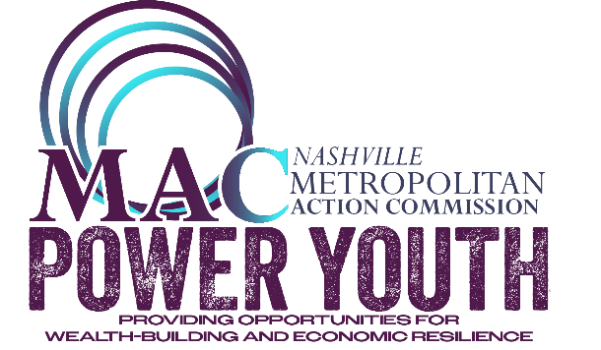
Company Information:
Company Name:

Company Address:

Site Address:

Company Website:

Company Description:

Nearest MTA Bus Stop:

Internship Information:
Format: (In-Person Only)

Positions Available:

Technology Used:

Internship Title:

Internship Description/Learning Objectives:

Job Duties:

Preferred Competencies:

General Information:
Work Schedule Days and Hours:

Dress Code:

Travel Required:

Physical Requirements:

Working Conditions: (example: Office Warehouse, Outdoors, with Children or Animals, etc.)

The full program is June 1st – July 17th
June 2nd – June 5th: Interns attend work readiness skills training from 8am – 12pm.
June 4th: POWER Youth Summit at Sheraton Music City Nashville Airport
June 8th – July 17th: Team Members on site at their agencies on Monday-Friday at the time
scheduled by employer. You will be scheduled to work 4 hours daily
which equals 20 hours per week.

July 17th: POWER Youth Summer Employment Program - End of Summer
Celebration – Team Members can showcase their projects from the
summer.

If you are selected as an Experience Work Team Member, you will make $12.00 an hour and receive a summer program with project-based employment for youth ages 14 -15.
Experience Work projects can be focused on the arts, leadership skills or community development. In addition, you will learn “work ready” skills for future employment. There are opportunities to intern in many areas of Nashville, so please select the opportunity based on your access to transportation.

